Mincemeat

Add "Mincemeat" to FavouritesAdd to Favourites

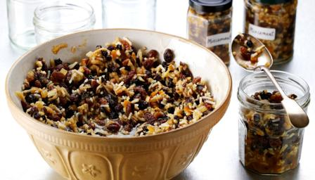
This traditional mincemeat recipe is simple, straight-forward and only takes minutes to make.

Ingredients
- 225g/8oz vegetarian suet
- 225g/8oz Bramley apples, peeled, cored and chopped
- 125g/4oz candied peel, chopped
- 225g/8oz sultanas
- 225g/8oz raisins
- 225g/8oz currants
- 175g/6oz demerara sugar
- 1 tsp mixed spice
- 1 orange, zest and juice
- 60ml/2fl oz brandy

Preparation method
- Mix all the ingredients together.
- Pack into sterilised jars and seal.
- Store in a cool dark place until you want to use it.

Required techniques

